**Axis IPO Portal**

**Technologies to be used for development:**

Creating an Axis IPO portal using MySQL, Spring Boot with JPA Hibernate, and React involves several steps. Here's a high-level overview of the process:

**Database Design:**

* Start by designing the database schema to store relevant information for the IPO process.
* Define tables for users, IPO applications, documents, etc. Make sure to establish appropriate relationships between entities.

**Backend Development (Spring Boot):**

* Set up a Spring Boot project using Maven.
* Configure the MySQL database connection in the application properties file.
* Create JPA entity classes to represent the database tables.
* Implement repositories (DAO) using JPA/Hibernate to interact with the database.
* Build the service layer to encapsulate the business logic for IPO.
* Implement REST APIs using Spring Web to handle CRUD operations for users, IPO applications, and documents.
* Handle file upload for documents using Spring's Multipart support.
* Implement necessary validations and error handling in the APIs.
* Set up Spring Security to handle user authentication and authorization – (session based).
* Swagger

**Frontend Development (HTML, CSS)**

**Microservice Architecture:**

* In this architecture, the backend and frontend are tightly integrated into a single application. So, combine the backend (Spring Boot) and frontend (React) projects into a single application structure.
* Configure the build process to generate a single deployable artifact (e.g., a WAR or JAR file) that includes both backend and frontend resources.

**Testing:**

* Write unit tests for the backend using JUnit and Mockito to ensure the correctness of service and repository classes.
* Implement integration tests to verify the API endpoints' behavior.
* Conduct manual testing of the user interface for a smooth user experience.

**Roles**

1. Employee (For Merchant Creation)
2. Employee (For Merchant Enquiry)
3. Employee (For Merchant Approval)
4. Admin

**Work Flow to understand the user experience for Project**

Sure, let's elaborate on the user experience workflow for the "Axis IPO portal" covering all the user roles and their respective modules and functionalities:

**1) Employee Role (For Merchant Enquiry) User Experience Workflow:**

After logging in, the Employee can access the following features:

* Upon login, the Employee is directed to the dashboard displaying features for merchant enquiry
* In the Enquiry Portal, the Employee can search for a merchant using the Virtual Payment Address (VPA) and its details and other relevant information. (Email, phone).

**2) Employee Role (For Merchant Creation) User Experience Workflow:**

* After filling the form fields, system validates the contents for each merchant.
* Appropriate error messages are displayed if the contents has incorrect data (validations).
* Apply for onboarding approval by clicking the "Submit" button for submitting the merchant record.

**NOTE:-**

1) VPA should be of the format either [xyzbse@axis](mailto:xyzbse@axis) or xyznse@axis.

If vpa contains word bse then it is considered as bse and we need to replace with nse and check for nse vpa availability and vice versa.

**For Example:-**

1. If vpa is [xyzbse@axis](mailto:xyzbse@axis) , then replace it with [xyznse@axis](mailto:xyznse@axis) and check if it is present in the DB or not .If not then it is considered valid VPA else enter new VPA.
2. If vpa is [xyznse@axis](mailto:xyznse@axis) then check its availability in DB if not then it is a valid vpa else enter new VPA.

2) Once all the mandatory fields (refer the image below) are supplied it should go for approval . On successful approval of the supplied fields it should be saved in the DB.

3) Appropriate Success/Failure messages should be prompted in the application where ever required.

**3) Employee Role (For Merchant Approval) User Experience Workflow**:

After logging in, the Employee can access the following features:

**a) Multiple Merchant Details**

* Upload merchant details in bulk using a file upload feature.(Excel Sheet)
* After selecting the file, the system validates the format and contents for each merchant. Appropriate error messages are displayed if the file is not uploaded or has incorrect data (validations).
* Apply for onboarding approval by clicking the "Submit" button for submitting the merchant records
* Appropriate error messages should be prompted if the user clicks on submit button without selecting any file.

**b) Single Merchant Details**

Upload merchant details manually in the form :

After logging in, the Employee can access the following features:

* Act as the final approver to review the merchant records submitted by the Employee concerned with Creation of merchant.
* Either approve or reject the merchant records for onboarding.
* If approved, the merchant record is now marked as "Approved".
* If rejected, provide feedback to the Employee for necessary modifications.

NOTE: In the approval section also show the status i.e. Pending for Approval / Approved. Appropriate Success/Failure messages should be prompted in the application where ever required.

**4) Admin Role User Experience Workflow:**

* View user roles and access permissions.
* Approved merchant details can be changed , and if update happens it will go through creation and approval process
* Enquiry trail-- It will contain update history like when batch is created, how many times it has gone through updation process i.e. how many times it has been changed.

**NOTE:** - If the user has selected add for both NSE and BSE checkbox in add merchant option, then in such scenario 2 records will be sent for approval , one for NSE VPA and other for BSE VPA. Either both will be approved or both will be rejected.

Create a login page for the above application which only allows authorized users to login and modify. Appropriate error messages should be displayed on invalid user login.

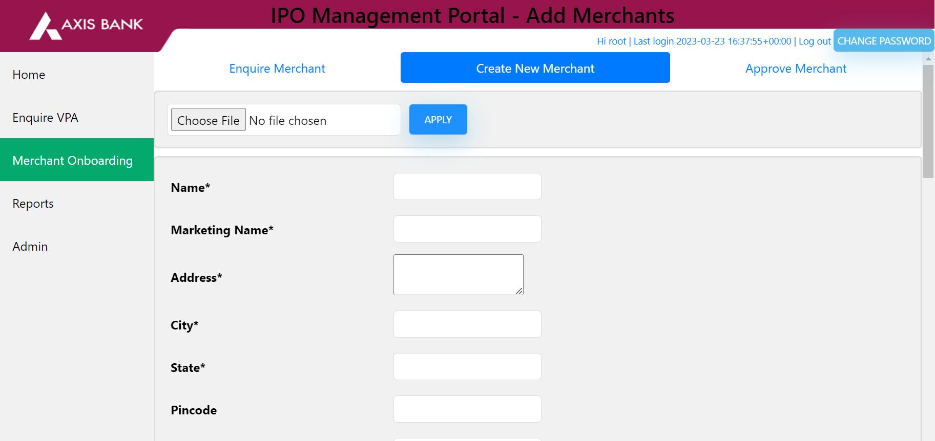

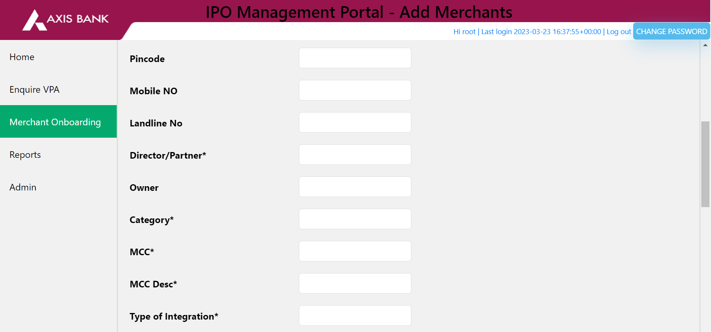

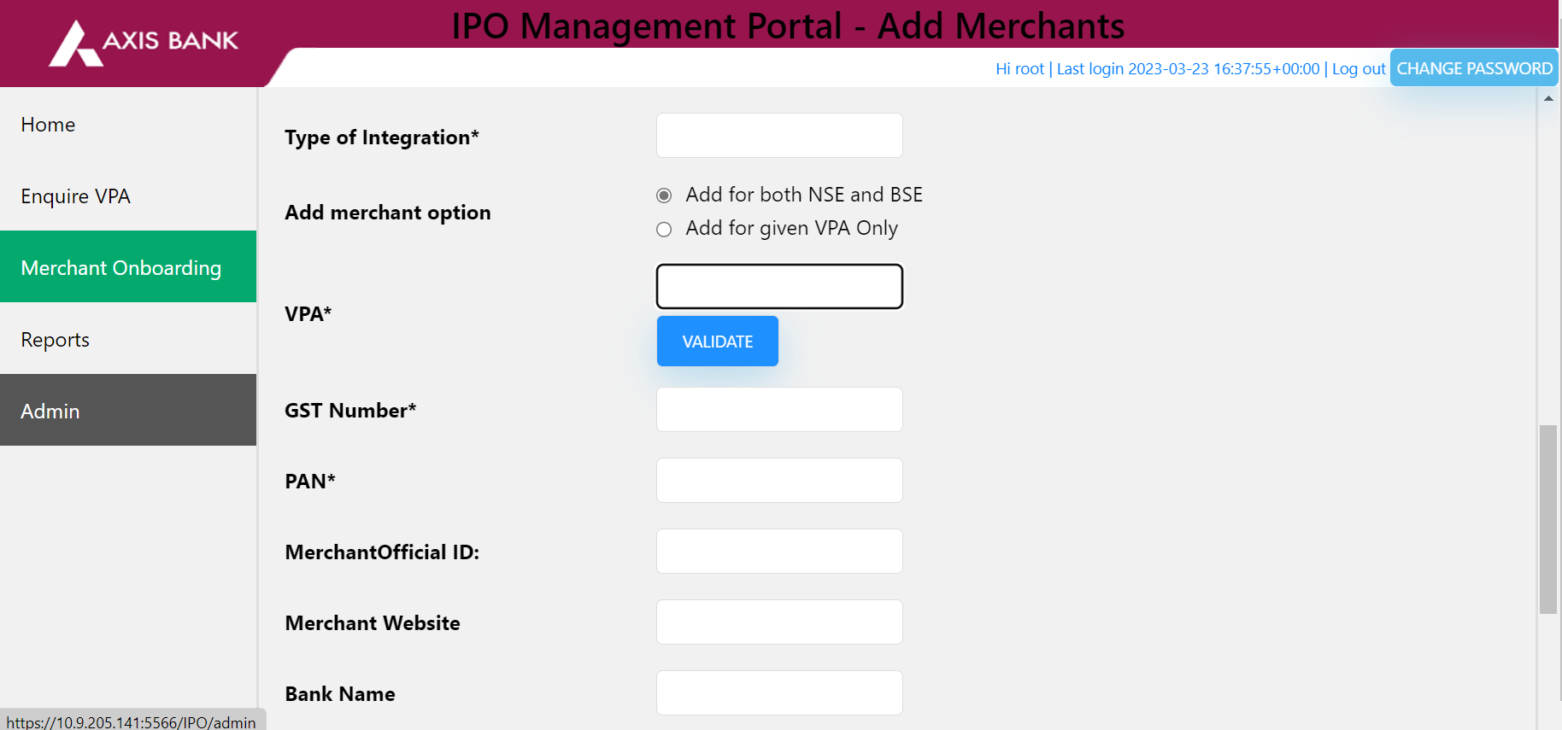

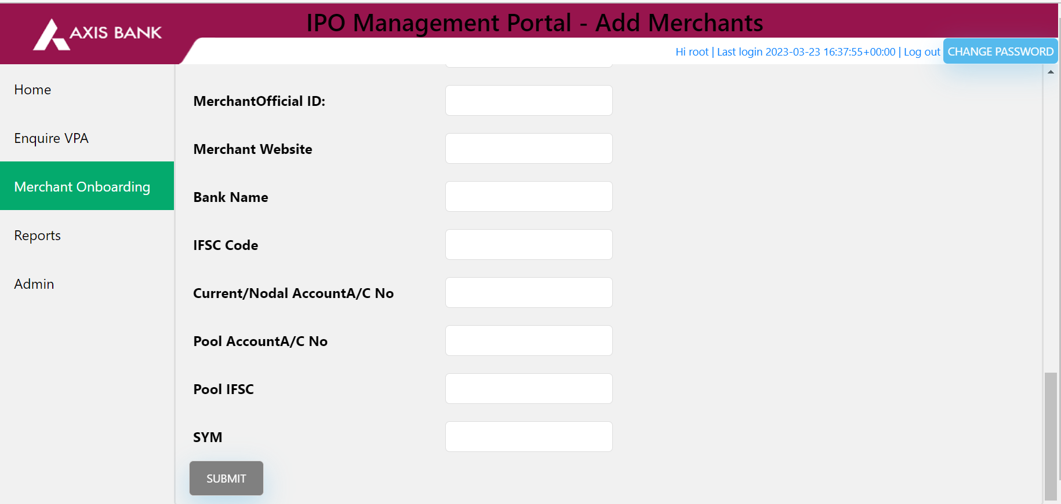

This project will help end users to automatically on-board new merchants in IPO portal.

**Project Description:**

1. Create a front end option to Create and Approve new merchants.
2. (i)The users should be able to choose a file containing required fields and upload in the portal which will later prepopulate the fields in the frontend. NOTE: Appropriate error messages should be prompted if the user clicks on submit button without selecting any file.

(ii) If the user doesn’t upload the file then the fields have to been filled manually by the users.

1. Once the required fields are filled either manually by user or pre-populated by uploading a file the next step is approval. Once all the fields are approved the data should be saved in a Database and the same should be displayed in the approval tab.
2. In the approval section also show the status i.e Pending for Approval / Approved.